**ORIGINAL INSTRUCTIONS**



**HEDGE TRIMMER**

**RAY600EHT**

**INSTRUCTIONS MANUAL**

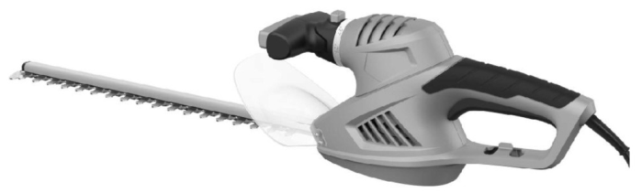

APPROVED BY DEKRA 28/02/17

Laurent Asty



**WARNING: READ THE FOLLOWING INSTRUCTIONS BEFORE USE THIS MACHINE**

**32, rue Aristide Bergès - ZI 31270 Cugnaux – France **

**MADE IN PRC 2017**

**CONTENTS**

1. SAFETY WARNINGS 3
2. YOUR TOOL 7
3. UTILISATION 9
4. MAINTENANCE AND STORAGE 11
5. DISPOSAL 11
6. DECLARATION OF CONFORMITY 12
7. **SAFETY WARNINGS**

** WARNING Read all safety warnings and all instructions.** *Failure to follow the warnings and instructions may result in electric shock, fire and/or serious injury*.

**Save all warnings and instructions for future reference.** *The term "power tool" in the warnings refers to your mains-operated (corded) power tool or battery-operated (cordless) power tool.*

1) **Work area safety**

a) **Keep work area clean and well lit**. *Cluttered or dark areas invite accidents.*

b) **Do not operate power tools in explosive atmospheres, such as in the presence of flammable liquids, gases or dust.** *Power tools create sparks which may ignite the dust or fumes.*

c) **Keep children and bystanders away while operating a power tool.** *Distractions can cause you to lose control.*

2) **Electrical safety**

a) **Power tool plugs must match the outlet. Never modify the plug in any way. Do not use any adapter plugs with earthed (grounded) power tools.** *Unmodified plugs and**matching outlets will reduce risk of electric shock.*

b) **Avoid body contact with earthed or grounded surfaces, such as pipes, radiators, ranges and refrigerators.** *There is an increased risk of electric shock if your body is**earthed or grounded.*

c) **Do not expose power tools to rain or wet conditions.** *Water entering a power tool will increase the risk of electric shock.*

d) **Do not abuse the cord. Never use the cord for carrying, pulling or unplugging the power tool. Keep cord away from heat, oil, sharp edges or moving parts.** *Damaged**or entangled cords increase the risk of electric shock.*

e) **When operating a power tool outdoors, use an extension cord suitable for outdoor use.** *Use of a cord suitable for outdoor use reduces the risk of electric shock.*

f) **If operating a power tool in a damp location is unavoidable, use a residual current device (RCD) protected supply.** *Use of an RCD reduces the risk of electric shock.*

NOTE the term “residual current device (RCD)” may be replaced by the term “ground fault circuit interrupter (GFCI)” or “earth leakage circuit breaker (ELCB)”.

3) **Personal safety**

a) **Stay alert, watch what you are doing and use common sense when operating a power tool. Do not use a power tool while you are tired or under the influence of drugs, alcohol or medication.** *A moment of inattention while operating power tools**may result in serious personal injury.*

b) **Use personal protective equipment. Always wear eye protection.** *Protective equipment such as dust mask, non-skid safety shoes, hard hat, or hearing protection used for appropriate conditions will reduce personal injuries.*

c) **Prevent unintentional starting. Ensure the switch is in the off-position connecting to power source and/or battery pack, picking up or carrying the tool.** *Carrying power tools with your finger on the switch or energizing power tools that have**the switch on invites accidents.*

d) **Remove any adjusting key or wrench before turning the power tool on.** *A wrench or a key left attached to a rotating part of the power tool may result in personal injury.*

e) **Do not overreach. Keep proper footing and balance at all times.** *This enables better control of the power tool in unexpected situations.*

f) **Dress properly. Do not wear loose clothing or jewelry. Keep your hair, clothing and gloves away from moving parts.** *Loose clothes, jewelry or long hair can be**caught in moving parts.*

g) **If devices are provided for the connection of dust extraction and collection facilities, ensure these are connected and properly used.** *Use of dust collection can**reduce dust-related hazards*.

4) **Power tool use and care**

a) **Do not force the power tool. Use the correct power tool for your application.** *The correct power tool will do the job better and safer at the rate for which it was designed.*

b) **Do not use the power tool if the switch does not turn it on and off.** *Any power tool that cannot be controlled with the switch is dangerous and must be repaired.*

c) **Disconnect the plug from the power source and/or the battery pack from the power tool before making any adjustments, changing accessories, or storing power tools.** *Such preventive safety measures reduce the risk of starting the power**tool accidentally.*

d) **Store idle power tools out of the reach of children and do not allow persons unfamiliar with the power tool or these instructions to operate the power tool.** *Power tools are dangerous in the hands of untrained users.*

e) **Maintain power tools. Check for misalignment or binding of moving parts,****breakage of parts and any other condition that may affect the power tool’s****operation. If damaged, have the power tool repaired before use.** *Many accidents are caused by poorly maintained power tools.*

f) **Keep cutting tools sharp and clean.** *Properly maintained cutting tools with sharp cutting edges are less likely to bind and are easier to control.*

g) **Use the power tool, accessories and tool bits etc. in accordance with these instructions, taking into account the working conditions and the work to be performed.** *Use of the power tool for operations different from those intended could result in a hazardous situation.*

5) **Service**

a) **Have your power tool serviced by a qualified repair person using only identical replacement parts*.*** *This will ensure that the safety of the power tool is maintained*

**Hedge trimmer safety warnings:**

* **Keep all parts of the body away from the cutter blade. Do not remove cut material or hold material to be cut when blades are moving. Make sure the switch is off when clearing jammed material.** *A moment of inattention while operating the hedge trimmer may**result in serious personal injury.*
* **Carry the hedge trimmer by the handle with the cutter blade stopped. When transporting or storing the hedge trimmer always fit the cutting device cover**. *Proper**handling of the hedge trimmer will reduce possible personal injury from the cutter blades.*
* **Keep cable away from cutting area.** *During operation the cable may be hidden in shrubs**and can be accidentally cut by the blade*
* It is recommended to use a residual differential device with a cut-off current of less than or equal to 30 mA.
* Check for any foreign objects in the hedge, such as wire fences.
* Hold the hedge trimmer correctly, for example with both hands if it is equipped with two handles.
* Anyone who uses or performs maintenance work on this machine must be familiar with these instructions and are aware of possible hazards. Prevent children, sick people or not able to use the machine. While you are standing in the work area, be aware of the presence of children
* Observe local or regional safety measures in your area. This also applies to all provisions relating to safety at the workplace and to health prevention in the workplace
* The manufacturer cannot be held responsible if the machine has been modified in an unauthorized manner or in such a way as to constitute a final damage.
* Observe the nature of the area where the work is being performed.
* After the machine is started, it generates toxic exhaust gases. These gases are invisible and odourless. Therefore, it is imperative never to use the machine in enclosed or poorly ventilated spaces.
* When cutting, make sure you have good lighting.
* Ensure your stability when working on slopes or on irregular surfaces or in the presence of moisture, snow or frost.
* Do not allow unauthorized persons to approach the machine. Visitors and spectators, especially children, the sick or the disabled, must not have access to the work area.
* Take precautions when storing the tool. When the machine is not in use, it must be stored in a dry, if possible high or protected place, in order to prevent access.
* Use the tool for the tasks you want to perform. In this context, it is advisable, for example, to avoid using a tool or a small accessory for a job requiring the use of a heavy tool.
* Use the tool only for the purpose for which it was designed.
* Wear appropriate clothing. Your outfit should be appropriate to work and not bother you. Wear protective clothing that protects against cuts.
* Use personal protective equipment. This includes at least: safety shoes, goggles, ear protectors, protective gloves, etc.
* Never use an unsafe cutting tool. There is a risk of injury from projected objects.
* Before starting the trimmer, remove all the keys and check that the tool is securely assembled.
* Stay alert at all times. Be attentive to what you are doing. Make use of your common sense. Do not use the tool when you are tired. Do not use the tool under the influence of alcohol, drugs or drugs that alter or decrease concentration. Also, do not use the tool when you are sick.
* After using the machine for an extended period of time, you may experience circulation problems in your hands. Extend the duration of use by wearing appropriate gloves and taking regular breaks. Please note that the running time of the motorized machine is shortened due to user discomfort due to poor circulation, too low outside temperature or excessive machine driving power during the works.
* Take account of damaged components. Check the machine before using it. Damaged components must be repaired or replaced as soon as possible by authorized persons. Defective switches must be replaced by an authorized dealer. Do not use the machine if it cannot be turned off or turned on with a switch. When repairs are required, please contact your nearest dealer.
* Before any adjustment or maintenance operation, the motor must always be switched off. This also applies to all work performed on the cutting head and the removal of the spark plug from the engine.
* Use only approved components. Use only identical replacement parts as replacements during maintenance or repair work. Contact your authorized dealer for advice. Do not use metal swivel chains and flail blades.
* When transporting and storing the tool, make sure it is secure. Put the protective device on the blade when the machine is to be transported, stored, cleaned and maintained
* To avoid damage or injury, be careful when handling and transporting the tool. Do not forget to put the protective device on the blade each time.
* Do not use the device when you are tired, sick under the influence of alcohol or drugs.
* Use only accessories and protections recommended by the manufacturer. It is recommended that your dealer provide a list of recommended accessories if necessary. Use of parts not recommended by the manufacturer may result in personal injury, accident and malfunction of the tool.
* Maintain a good balance when using the tool. Stay firm feet on the ground so as not to fall. Do not lean too much, do not put yourself in positions that may unbalance and hurt you. Use the harness supplied with the tool.
* Periodically check that the cutting elements stop when the machine is idling.
* Warning! The use of another cutting head or other accessories and extensions, even when specifically recommended, may result in injury or property damage.
* The machine must not be used for purposes other than those intended. Any divergent use of these purposes must therefore be considered as unauthorized use. The user is solely responsible, thereby systematically releasing the manufacturer from any liability for personal injury or damage resulting from such unauthorized use.
* The manufacturer's warranty is void if the machine to which it was designed has been transformed or used in an unauthorized manner and if such a situation results in damage.
* Keep persons at a minimum distance of 15 mm from the work area.

**Intended Use**

Your hedge trimmer is a device used by a person to cut hedges and shrubs by working with one or more blades arranged linearly and back and forth. A potential hazard exists if the device is used for other purposes. Improper handling of the hedge trimmer increases the risk of blade injury. Only the use of spare parts and accessories approved by the manufacturer is permitted.

**Residual risks**

• Cuts from the blade

• Inhalation of particles of material to be cut

• Projection of the parts of the cutting blades

• Contact with uncovered cutting head (wounds, cuts)

• Contact with tool in operation (injuries, cuts)

• Development of toxic dusts / fumes when used in confined spaces (vomiting / nausea)

• Hearing loss in the absence of proper hearing protection

WARNING! This machine generates an electromagnetic field during its operation. This field may under certain circumstances disrupt the functioning of active or passive medical implants. To reduce the risk of serious injury or death, people with medical implants should consult with their physician and the implant manufacturer before using this machine.

**Symbols**

 Warning symbol

****Read the instructions manual

 Wear an ocular protection

****Wear a hearing protection

 Remove immediately the power plug from power supply if the cable is damaged or cut.

 Do not expose to rain or humidity

 Guarantee noise level

 Class II symbol

1. **YOUR TOOL**
2. **Description**

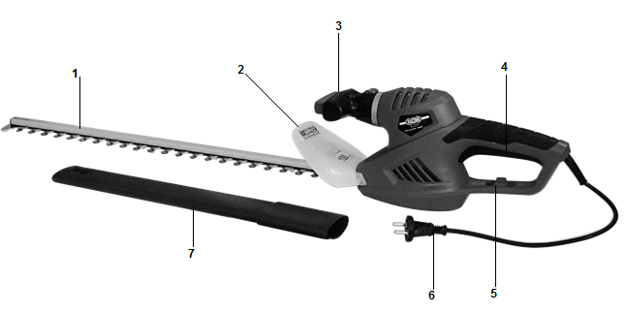

1. Blade
2. Protection
3. Pivoting handle
4. Rear handle +switch
5. Cable holder
6. Power plug
7. Blade protection
8. **Technical data**

|  |  |
| --- | --- |
| **Model** | RAY600EHT |
| **Tension** | 230-240Vac, 50Hz |
| **Power** | 600W |
| **Non load speed** | 1600min-¹ |
| **Cutting length** | 610mm |
| **Cutting capacity** | 16mm |
| **Sound pressure level**  **Uncertainty K** | Lpa = 88.6dB(A)  K = 3dB |
| **Sound pressure level**  **uncertainty K** | Lwa = 96.5dB(A)  K = 3dB |
| **Guarantee sound power** | Lwa = 100dB(A) |
| **Vibration K**  **Uncertainty** | Front handle: 2.718m/s2  Rear handle: 2,164m/s2  1,5m/s2 |

Information:

The declared vibration total value has been measured in accordance with a standard test method and may be used for comparing one tool with another;

The declared vibration total value may also be used in a preliminary assessment of exposure.

Warning:

That the vibration emission during actual use of the power tool can differ from the declared total value depending on the ways in which the tool is used; and

of the need to identify safety measures to protect the operator that are based on an estimation of exposure in the actual conditions of use (taking account of all parts of the operating cycle such as the times when the tool is switched off and when it is running idle in addition to the trigger time).

1. **UTILISATION**
2. **Installation of the protection**

If not installed, install the protection to the tool. Screw it with the 4 provided screws.

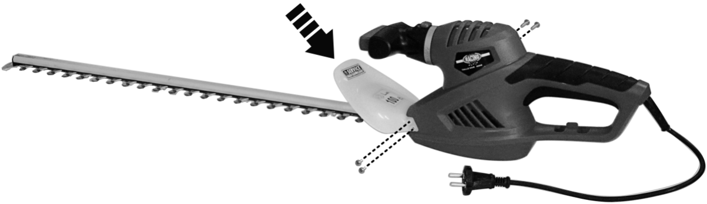

1. **Before cutting**

* Make sure that the tool is properly assembled.
* Inspect the work area. Remove any materials or objects that may damage the tool or cause accidents.
* Remember that you must wear full protective gear and keep spectators away from the work area.
* Connect the tool with a valid extension cable (if necessary), then plug the extension into a power outlet.
* Be careful to have a good walk and balance. Hold the tool with both hands firmly and keep it at an ideal distance from your body.
* Hold the tool firmly, one hand holding the handle and the other holding the pole.
* Make sure the extension cord is out of your work area. Never put the cable on the trimmer because the cable can be cut easily by the blades.
* When bumping solid objects and you are stuck, you must immediately turn off the machine, remove the plug and remove the object.
* Always operate in such a way that the cable and plug are set aside. Before starting work, determine the cutting direction.

1. **Switch the tool on and off**
   * Plug the tool to an extension cord. The extension cord must be connected to an adequate socket.
   * When plug the power plug to the extension cord, add it in the cable holder as showed in below image

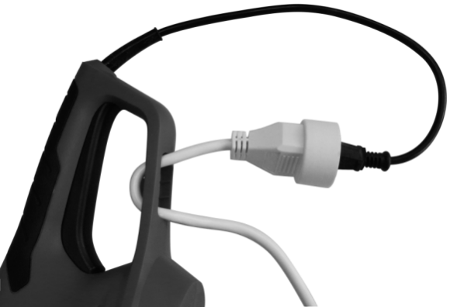

* + Press and hold the rear handle switch. Press the front handle switch to start the machine.
  + To stop the machine, release the front switch and then the switch on the rear handle.  
      
    **Note: Starting the machine can also be done by holding the front handle and starting by pressing the switch on the rear handle. It depends on your work position.**

1. **Pivoting handle**

You can change the position of the front handle according the work position you must have. Push and hold the handle button. Turn the handle on the left or right to choose the position. Release the button to lock the position

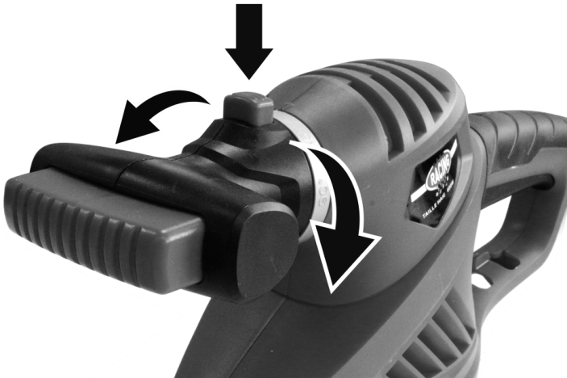

1. **Cutting Techniques**
   * Move the vertical section of the electric trimmer uniformly forward or bend up and down.
   * In order to keep long straight lines, we recommend stretching the cables.
   * It is recommended to cut the trapezoidal hedges to prevent the lower branches from being stripped. This corresponds to the natural growth of plants and hedges can be potentially prosperous. The cut makes the new annual shoots reduced, so a dense branching and a good protection of the sight must be considered.
   * First cut the edges of a hedge. Move the hedge trimmer to cut the part that grows greatly from bottom to top. If you cut from top to bottom, the thinner branches move outward; Narrow places or holes may form.
   * Cut the top of the hedge, just like a roof or a round shape.
   * Cut the seedlings into the desired shape. The main stem must be intact and remain until the hedge reaches the proposed elevation. All other shoots should be cut to half.
2. **MAINTENANCE AND STORAGE**

Maintain your tool regularly. This will keep your tool in good working order and extend its lifespan.  
Do not use abrasive, caustic agents to clean the tool. These types of products will damage your tool.

Do not perform repairs by yourself. Repairs and inspection must be carried out by a competent person or at an authorized service center (please contact you service dealer).

1. **After each use**

Check the blade, cable and body of the tool (cleanliness, wear, damage, etc.). If you notice damage, wear, or malfunction, do not use the tool and bring it to a qualified service for inspection and reparation.

1. **Maintenance**  
   There is no specific maintenance to be performed by the user. After each season, please bring the tool to an authorized service center to perform a general cleaning and the following operations:
   * Lubrication of the blade
   * Mechanical check of motor, spindle, bearings and housing.
   * Electrical check.
   * Electrical and mechanical performance.
2. **Spare Parts**

You can order the spare parts directly from our Service Center. Please place your order according to the type of the machine and the parts number given in the explosion drawing.



1. **Storage**

* After use and cleaning, please store your tool.
* Store the tool in a clean, dry place, preferably in its box.
* During transport and storing always put the protection cover on the blade.
* The tool must be stored away from children and pets.
* Avoid exposing the tool to direct sunlight.

1. **DISPOSAL**



Electrical products should not be discarded with household products. According to the European Directive 2012/19/UE on waste electrical and electronic equipment and its implementation into national law, electrical products used must be collected separately and disposed of at collection points provided for this purpose. Talk with your local authorities or dealer for advice on recycling.

1. **DECLARATION OF CONFORMITY**



**EC Declaration of conformity**

**HYUNDAI**

**32, rue Aristide Bergès - ZI 31270 Cugnaux – France declare that the machine**

**Designation: HEDGE TRIMMER**

**Model: RAY600EHT**

**Serial number: 20170613623-20170614624**

**Is in conformity with the European Directives:**

Machine Directive 2006/42/EC

EMC Directive 2014/30/EU

Noise emission Directive 2000/14/EC Annex V + 2005/88/EC

ROHS Directive 2011/65/EU

**Sound power level:**

Guaranteed: 100dB(A);

Measured: 96.5dB(A)

**This product is also in conformity with the following standards:**

EN60745-1:2009+A11:2010

EN60745-2-15:2009+A1:2010

EN 55014-1:2006+A1:2009+A2:2011

EN 55014-2:2015

EN61000-3-2:2014

EN61000-3-3:2013

**The technical documentation is kept by: Olivier Patriarca**

Philippe MARIE / PDG

Cugnaux, 01/03/2017

